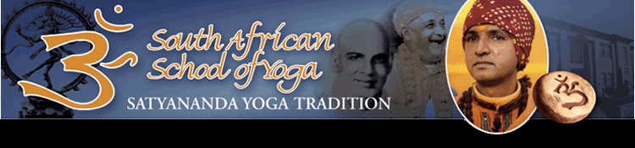

Newsletter April 2014 No 38

A synopsis of The Bihar/ Satyananda Yoga Tradition for all our students at the South African School of Yoga
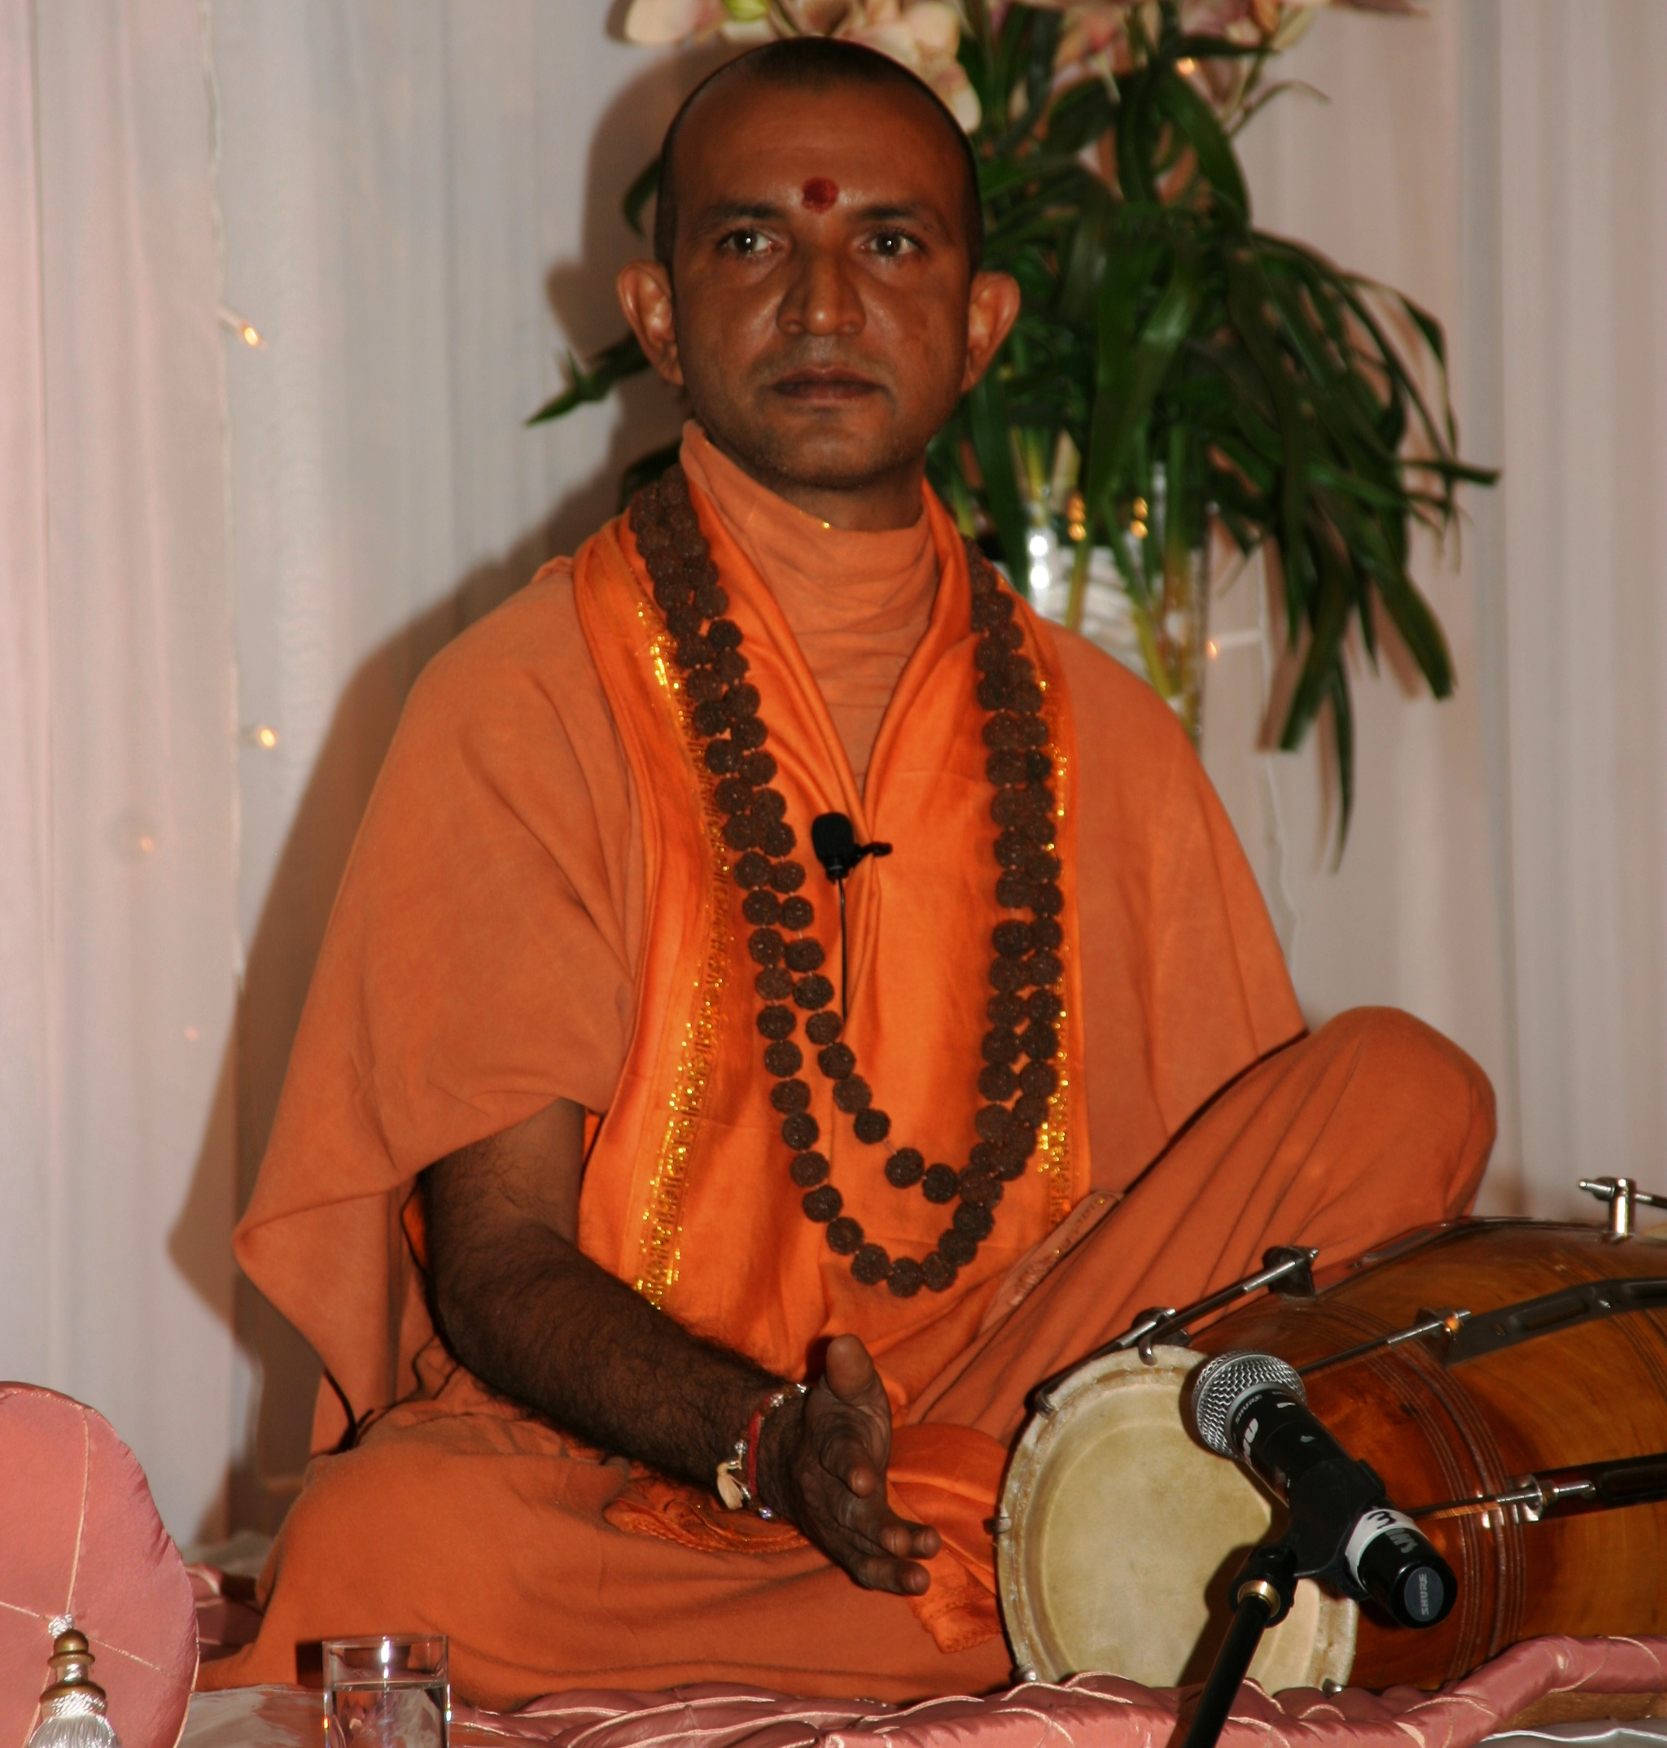
“At the beginning off the 21st century, human kind stands at a cross road. Technological progress and economic development have created immense wealth for some, but not for all. Globalisation has linked the world out of economic necessity, rapid urbanisation has harmed the environment and disconnected the individual from nature. Voices are raised about pollution, environmental damage, both inner and outer, and the need to uplift the poor. On an inner level, people are unhappy, unhealthy, stressed and unsure about the direction of life. There is increasing awareness that human beings have a choice about whether to blindly pursue a non-existent utopia or to live in harmony and find inner fulfilment.

Bihar/ Satyananda Yoga system is a complete science of harmonious living, suitable for everyone, regardless of age, gender, nationality, religion, mental condition or level of fitness. It is a holistic system which addresses all aspects of human life, in the spheres of physical health, mental well-being, emotional behaviour and work environment. AWARENESS is emphasized and practitioners are encouraged to learn about all aspects of their personality through Yoga. Adjustment in stages is emphasized that is why it is slow, steady and systematic from beginners to intermediate through to advanced.

Experimentation and research has been one of the hallmarks of the Bihar/ Satyananda yoga tradition. Thus Bihar Yoga is a continuously evolving yoga, while at the same time, retaining its classical base.

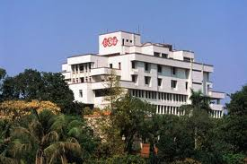

A full picture of the Bihar Yoga School in Munger, India.

Bihar Yoga has been effectively integrated into society all over the world for the development of human resources. Training programmes for the defence forces, prisons, the police force, railways, private and public organizations, sporting associations, education institutes, medical colleges, hospitals and for rural upliftment. The application of Bihar Yoga addresses current issues within society such as addiction, drug and alcohol rehabilitation, trouble or homeless teenagers, prisoners, abused women, HIV positive patients, as well as the physically and mentally challenged.

Bihar Yoga provides a system that restores order to our lives, creating harmony so that imbalances in the form of disease and neurosis drop away. The mind regains its peace, the emotions begin to harmonise and the body recovers its vital capacity, so that the individual can face life and its distractions with a greater sense of inner serenity and balance.

The beauty of Satyananda yoga is it slowly grows on one and it is totally up to the practitioner to decide how much to implement. If the need is relief from chronic diseases such as asthma, diabetes or hypertension, then a simple package of practices can be implemented. If the need is to improve one’s physical fitness or one’s mental abilities or take up yoga teaching, or find a direction in life, or live a spiritual life, then Bihar/Satyananda Yoga also provides that opportunity.”
---Swami Niranjanananda, from the International Yoga Convention 2013.
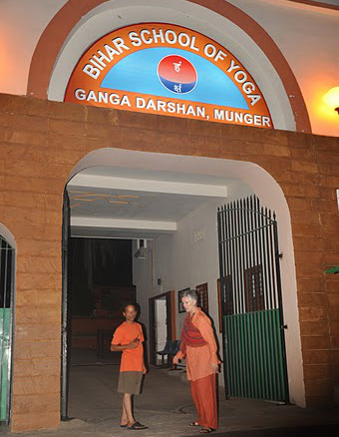

Swami Kamalavidya arriving at the entrance to the Bihar School of Yoga, Munger India. Where she visits every year.

South African School of Yoga announces…

The South Africa School of Yoga will be closed from Friday, the 18th of April 2014 and will re-open Tuesday, the 22nd of April 2014.

Although all schools are on holiday, the South African Yoga School will be open throughout.

Swami Kamalavidya wishes you all a Happy Easter and a good rest! And to our Jewish students a happy and safe Pesach!

Coming up in May 2014: Short water purification

Diarise Saturday the 10th of May 2014
Starting promptly at 09h00 to 10h30

Information will be forwarded after the long Easter weekend.

●HARI OM TAT SAT●

